Source(s):

<https://en.wikipedia.org/wiki/Non-breaking_space>

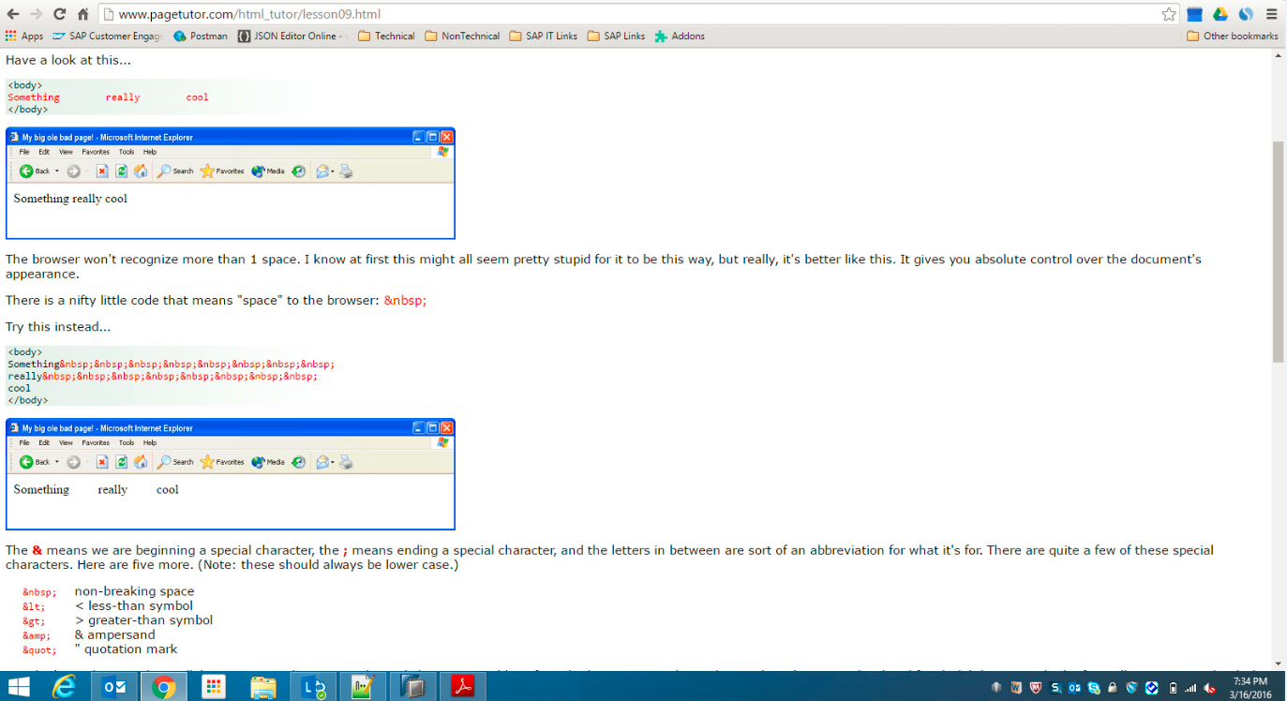

<https://en.wikipedia.org/wiki/Newline>

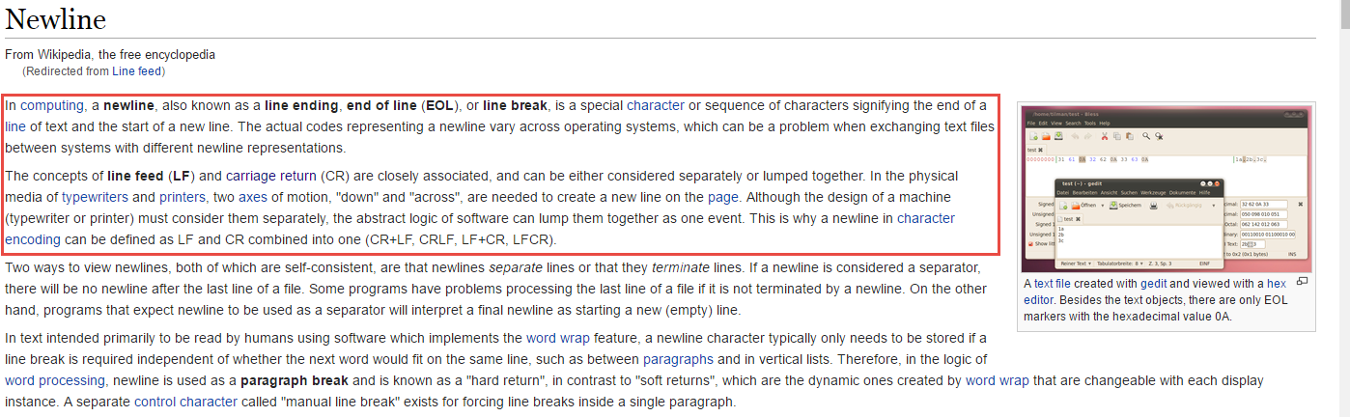

<https://en.wikipedia.org/wiki/Carriage_return>



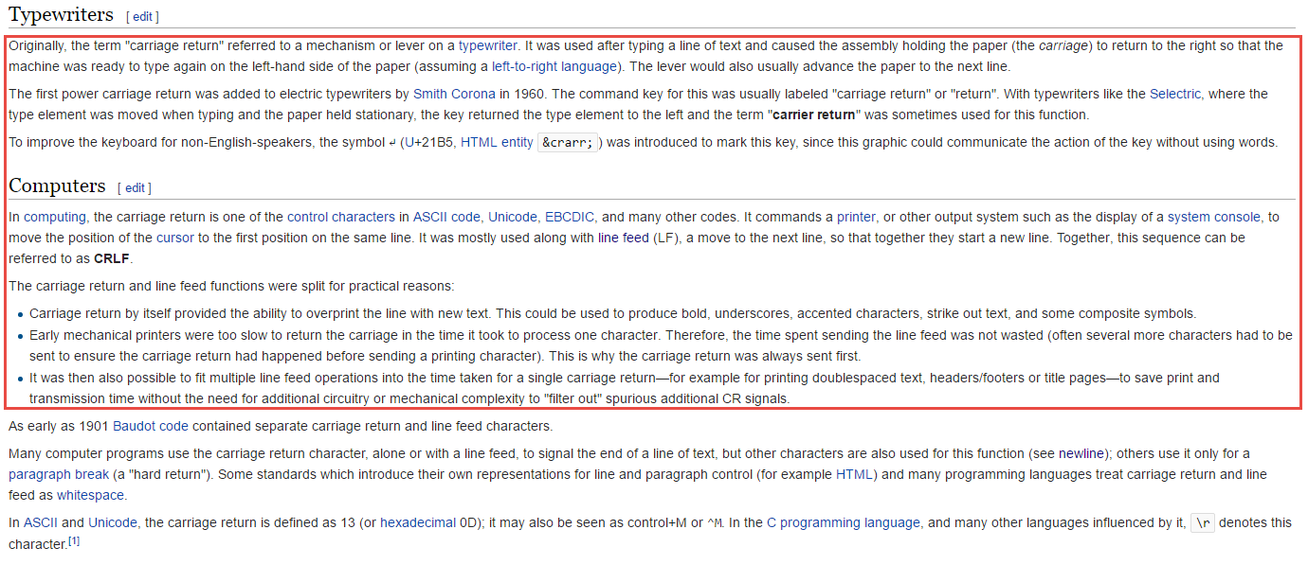

<https://en.wikipedia.org/wiki/Page_break#Form_feed>



<http://digital.ni.com/public.nsf/allkb/5A5A050A3019A573862575F30061D49B>

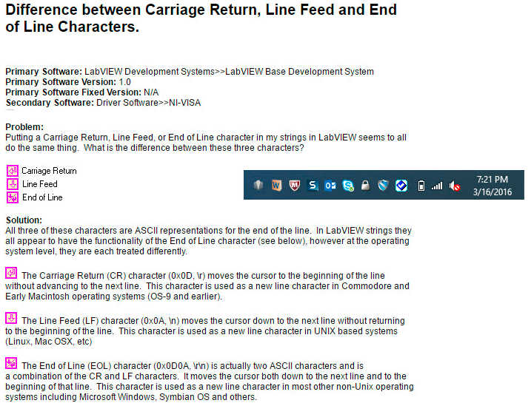

<http://stackoverflow.com/questions/12747722/what-is-the-difference-between-a-line-feed-and-a-carriage-return>

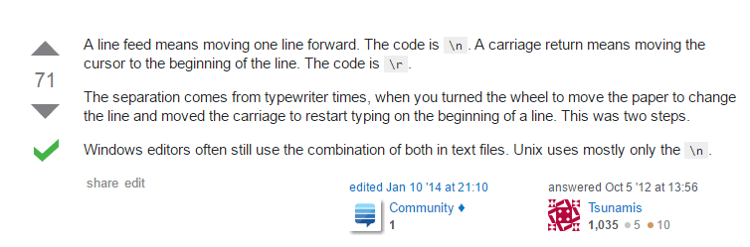

[http://stackoverflow.com/questions/12386803/carriage-return-line-feed-and-new-line#](http://stackoverflow.com/questions/12386803/carriage-return-line-feed-and-new-line)

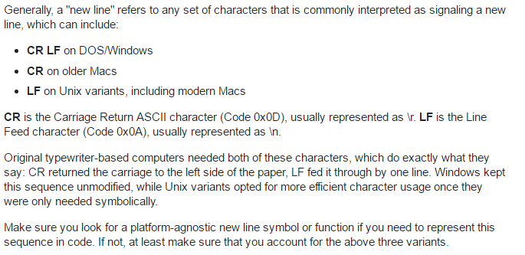

<https://en.wikipedia.org/wiki/Whitespace_character>

| [**Unicode character property**](https://en.wikipedia.org/wiki/Unicode_character_property)**"WSpace=Y"** | | | | | | | | | |
| --- | --- | --- | --- | --- | --- | --- | --- | --- | --- |
| [**Code point**](https://en.wikipedia.org/wiki/Code_point) | **Name** | **Decimal** | **Within”]["** | **Wrappable?** | **in**[**IDN**](https://en.wikipedia.org/wiki/Internationalized_domain_name)**?** | [**Script**](https://en.wikipedia.org/wiki/Script_(Unicode)) | [**Block**](https://en.wikipedia.org/wiki/Unicode_block) | **Gen.category** | **Notes** |
| U+0009 | character tabulation | 9 | ] [ | Yes | No | Common | Basic Latin | Other, control | HT, [Horizontal Tab](https://en.wikipedia.org/wiki/Horizontal_Tab). HTML/XML [named entity](https://en.wikipedia.org/wiki/List_of_XML_and_HTML_character_entity_references#Character_entity_references_in_HTML): &Tab;, [LaTeX](https://en.wikipedia.org/wiki/LaTeX" \o "LaTeX): '\tab' |
| U+000A | line feed | 10 |  |  |  | Common | Basic Latin | Other, control | LF, [Line feed](https://en.wikipedia.org/wiki/Line_feed). HTML/XML named entity: &NewLine; |
| U+000B | line tabulation | 11 |  |  |  | Common | Basic Latin | Other, control | VT, [Vertical Tab](https://en.wikipedia.org/wiki/Vertical_Tab) |
| U+000C | form feed | 12 |  |  |  | Common | Basic Latin | Other, control | FF, [Form feed](https://en.wikipedia.org/wiki/Form_feed) |
| U+000D | carriage return | 13 |  |  |  | Common | Basic Latin | Other, control | CR, [Carriage return](https://en.wikipedia.org/wiki/Carriage_return) |
| U+0020 | space | 32 | ] [ | Yes | No | Common | Basic Latin | Separator, space | Most common (normal ASCII space) |
| U+0085 | next line | 133 |  |  |  | Common | Latin-1 Supplement | Other, control | NEL, [Next line](https://en.wikipedia.org/wiki/Newline) |
| U+00A0 | no-break space | 160 | ] [ | No | No | Common | Latin-1 Supplement | Separator, space | [Non-breaking space](https://en.wikipedia.org/wiki/Non-breaking_space): identical to U+0020, but not a point at which a line may be broken. HTML/XML named entity: &nbsp;, LaTeX:'\ ' |
| U+1680 | ogham space mark | 5760 | ] [ | Yes | Yes | Ogham | Ogham | Separator, space | Used for [interword separation](https://en.wikipedia.org/wiki/Interword_separation" \o "Interword separation) in [Ogham](https://en.wikipedia.org/wiki/Ogham) text. Normally a vertical line in vertical text or a horizontal line in horizontal text, but may also be a blank space in "stemless" fonts. Requires an Ogham font. |
| U+2000 | en quad | 8192 | ] [ | Yes | No[[b]](https://en.wikipedia.org/wiki/Whitespace_character#cite_note-phishing-4) | Common | General Punctuation | Separator, space | Width of one [en](https://en.wikipedia.org/wiki/En_(typography)). U+2002 is canonically equivalent to this character; U+2002 is preferred. |
| U+2001 | em quad | 8193 | ] [ | Yes | No[[b]](https://en.wikipedia.org/wiki/Whitespace_character#cite_note-phishing-4) | Common | General Punctuation | Separator, space | Also known as "mutton quad". Width of one [em](https://en.wikipedia.org/wiki/Em_(typography)" \o "Em (typography)). U+2003 is canonically equivalent to this character; U+2003 is preferred. |
| U+2002 | en space | 8194 | ] [ | Yes | No[[b]](https://en.wikipedia.org/wiki/Whitespace_character#cite_note-phishing-4) | Common | General Punctuation | Separator, space | Also known as "nut". Width of one [en](https://en.wikipedia.org/wiki/En_(typography)). U+2000 En Quad is canonically equivalent to this character; U+2002 is preferred. HTML/XML named entity: &ensp;, LaTeX: '\enspace' |
| U+2003 | em space | 8195 | ] [ | Yes | No[[b]](https://en.wikipedia.org/wiki/Whitespace_character#cite_note-phishing-4) | Common | General Punctuation | Separator, space | Also known as "mutton". Width of one [em](https://en.wikipedia.org/wiki/Em_(typography)" \o "Em (typography)). U+2001 Em Quad is canonically equivalent to this character; U+2003 is preferred. HTML/XML named entity: &emsp;, LaTeX: '\quad' |
| U+2004 | three-per-em space | 8196 | ] [ | Yes | No[[b]](https://en.wikipedia.org/wiki/Whitespace_character#cite_note-phishing-4) | Common | General Punctuation | Separator, space | Also known as "thick space". One third of an em wide. HTML/XML named entity: &emsp13; |
| U+2005 | four-per-em space | 8197 | ] [ | Yes | No[[b]](https://en.wikipedia.org/wiki/Whitespace_character#cite_note-phishing-4) | Common | General Punctuation | Separator, space | Also known as "mid space". One fourth of an em wide. HTML/XML named entity: &emsp14; |
| U+2006 | six-per-em space | 8198 | ] [ | Yes | No[[b]](https://en.wikipedia.org/wiki/Whitespace_character#cite_note-phishing-4) | Common | General Punctuation | Separator, space | One sixth of an em wide. In computer typography, sometimes equated to U+2009. |
| U+2007 | figure space | 8199 | ] [ | No | No[[b]](https://en.wikipedia.org/wiki/Whitespace_character#cite_note-phishing-4) | Common | General Punctuation | Separator, space | [Figure space](https://en.wikipedia.org/wiki/Figure_space). In fonts with monospaced digits, equal to the width of one digit. HTML/XML named entity: &numsp; |
| U+2008 | punctuation space | 8200 | ] [ | Yes | No[[b]](https://en.wikipedia.org/wiki/Whitespace_character#cite_note-phishing-4) | Common | General Punctuation | Separator, space | As wide as the narrow punctuation in a font, i.e. the advance width of the period or comma.[[3]](https://en.wikipedia.org/wiki/Whitespace_character#cite_note-5) HTML/XML named entity:&puncsp; |
| U+2009 | thin space | 8201 | ] [ | Yes | No[[b]](https://en.wikipedia.org/wiki/Whitespace_character#cite_note-phishing-4) | Common | General Punctuation | Separator, space | One-fifth (sometimes one-sixth) of an em wide. Recommended for use as a [thousands separator](https://en.wikipedia.org/wiki/Thousands_separator" \o "Thousands separator) for measures made with [SI units](https://en.wikipedia.org/wiki/SI_units#SI_writing_style). Unlike U+2002 to U+2008, its width may get adjusted in typesetting.[[4]](https://en.wikipedia.org/wiki/Whitespace_character#cite_note-6) HTML/XML named entity: &thinsp;; Latex: '\,' |
| U+200A | hair space | 8202 | ] [ | Yes | No[[b]](https://en.wikipedia.org/wiki/Whitespace_character#cite_note-phishing-4) | Common | General Punctuation | Separator, space | Thinner than a thin space. HTML/XML named entity: &hairsp; |
| U+2028 | line separator | 8232 |  |  |  | Common | General Punctuation | Separator, line |  |
| U+2029 | paragraph separator | 8233 |  |  |  | Common | General Punctuation | Separator, paragraph |  |
| U+202F | narrow no-break space | 8239 | ] [ | No | No[[b]](https://en.wikipedia.org/wiki/Whitespace_character#cite_note-phishing-4) | Common | General Punctuation | Separator, space | [Narrow no-break space](https://en.wikipedia.org/wiki/Narrow_no-break_space). Similar in function to U+00A0 No-Break Space. When used with Mongolian, its width is usually one third of the normal space; in other context, its width sometimes resembles that of the [Thin Space](https://en.wikipedia.org/wiki/Thin_Space) (U+2009). |
| U+205F | medium mathematical space | 8287 | ] [ | Yes | No[[b]](https://en.wikipedia.org/wiki/Whitespace_character#cite_note-phishing-4) | Common | General Punctuation | Separator, space | MMSP. Used in mathematical formulae. Four-eighteenths of an em.[[5]](https://en.wikipedia.org/wiki/Whitespace_character#cite_note-7) In mathematical typography, the widths of spaces are usually given in integral multiples of an eighteenth of an em, and 4/18 em may be used in several situations, for example between the **a** and the **+** and between the **+** and the **b** in the expression**a + b**.[[6]](https://en.wikipedia.org/wiki/Whitespace_character#cite_note-8) HTML/XML named entity: &MediumSpace; |
| U+3000 | ideographic space | 12288 | ]　[ | Yes | No[[b]](https://en.wikipedia.org/wiki/Whitespace_character#cite_note-phishing-4) | Common | CJK Symbols and Punctuation | Separator, space | As wide as a [CJK](https://en.wikipedia.org/wiki/CJK) character cell ([fullwidth](https://en.wikipedia.org/wiki/Fullwidth" \o "Fullwidth)). Used, for example, in[tai tou](https://en.wikipedia.org/wiki/Tai_tou). |

| **Related whitespace characters without Unicode character property "WSpace=Y"** | | | | | | | | | |
| --- | --- | --- | --- | --- | --- | --- | --- | --- | --- |
| [**Code point**](https://en.wikipedia.org/wiki/Code_point) | **Name** | **Decimal** | **within "]["** | [**Wrap-   pable**](https://en.wikipedia.org/wiki/Non-breaking_space)**?** | **in**[**IDN**](https://en.wikipedia.org/wiki/Internationalized_domain_name)**?** | [**Script**](https://en.wikipedia.org/wiki/Script_(Unicode)) | [**Block**](https://en.wikipedia.org/wiki/Unicode_block) | **General  category** | **Notes** |
| U+180E | mongolian vowel separator | 6158 | ]᠎[ | Yes | Yes | Mongolian | Mongolian | Other, Format | MVS. A narrow space character, used in Mongolian to cause the final two characters of a word to take on different shapes.[[7]](https://en.wikipedia.org/wiki/Whitespace_character#cite_note-Gillam-9) It is no longer classified as space character (i.e. in Zs category) in Unicode 6.3.0, even though it was in previous versions of the standard. |
| U+200B | zero width space | 8203 | ]​[ | Yes | No[[b]](https://en.wikipedia.org/wiki/Whitespace_character#cite_note-phishing-4) | ? | General Punctuation | Other, Format | ZWSP, [zero-width space](https://en.wikipedia.org/wiki/Zero-width_space). Used to indicate word boundaries to text processing systems when using scripts that do not use explicit spacing. It is similar to the [soft hyphen](https://en.wikipedia.org/wiki/Soft_hyphen), with the difference that the latter is used to indicate syllable boundaries, and should display a visible hyphen when the line breaks at it. HTML/XML [named entity](https://en.wikipedia.org/wiki/List_of_XML_and_HTML_character_entity_references#Character_entity_references_in_HTML): &NegativeMediumSpace; |
| U+200C | zero width non-joiner | 8204 | ]‌[ | Yes | Yes | ? | General Punctuation | Other, Format | ZWNJ, [zero-width non-joiner](https://en.wikipedia.org/wiki/Zero-width_non-joiner). When placed between two characters that would otherwise be connected, a ZWNJ causes them to be printed in their final and initial forms, respectively. HTML/XML named entity: &zwnj; |
| U+200D | zero width joiner | 8205 | ]‍[ | Yes | Yes | ? | General Punctuation | Other, Format | ZWJ, [zero-width joiner](https://en.wikipedia.org/wiki/Zero-width_joiner). When placed between two characters that would otherwise not be connected, a ZWJ causes them to be printed in their connected forms. HTML/XML named entity:&zwj; |
| U+2060 | word joiner | 8288 | ]⁠[ | No | Yes | ? | General Punctuation | Other, Format | WJ, [word joiner](https://en.wikipedia.org/wiki/Word_joiner). Similar to U+200B, but not a point at which a line may be broken. HTML/XML named entity: &NoBreak; |
| U+FEFF | zero width non-breaking space | 65279 | ]﻿[ | No | Yes | ? | Arabic Presentation Forms-B | Other, Format | [Zero-width non-breaking space](https://en.wikipedia.org/wiki/Zero-width_non-breaking_space). Used primarily as a [Byte Order Mark](https://en.wikipedia.org/wiki/Byte_Order_Mark). Use as an indication of non-breaking is deprecated as of Unicode 3.2; see U+2060 instead. |